# Gaming Gambler

## Definition

**# Source**: **Chatgpt (GPT-5-Standard) at [8/27/2025]**

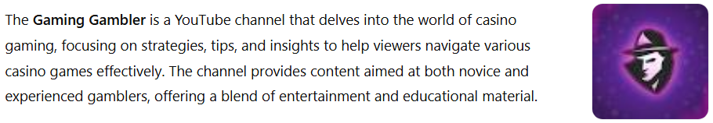

The **Gaming Gambler** is a YouTube channel that delves into the world of casino gaming, focusing on strategies, tips, and insights to help viewers navigate various casino games effectively. The channel provides content aimed at both novice and experienced gamblers, offering a blend of entertainment and educational material.

## Key Highlights

**# Source**: **Chatgpt (GPT-5-Standard) at [8/27/2025]**

* **Content Focus**: The channel covers a range of casino games, including slots, blackjack, and roulette, providing viewers with strategies and tips to enhance their gaming experience.
* **Educational Approach**: Content is designed to educate viewers on the nuances of casino gaming, helping them understand the odds, strategies, and best practices to improve their chances of success.
* **Entertainment Value**: While educational, the channel also aims to entertain, featuring engaging content that keeps viewers interested and coming back for more.
* **Community Engagement**: The Gaming Gambler fosters a community of like-minded individuals interested in casino gaming, encouraging discussions and sharing of experiences among viewers.([en.wikipedia.org](https://en.wikipedia.org/wiki/Vegas_Matt?utm_source=chatgpt.com))

## Summary Table

**# Source**: **Chatgpt (GPT-5-Standard) at [8/27/2025]**

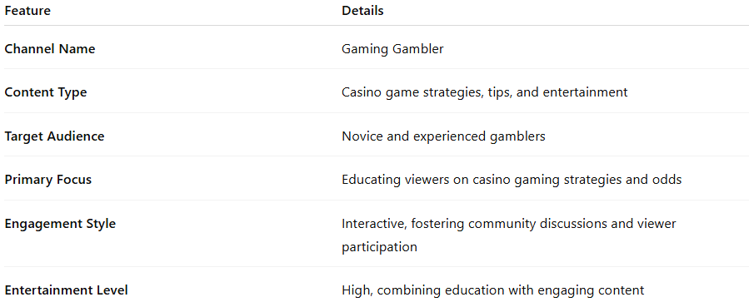

| **Feature** | **Details** |
| --- | --- |
| **Channel Name** | Gaming Gambler |
| **Content Type** | Casino game strategies, tips, and entertainment |
| **Target Audience** | Novice and experienced gamblers |
| **Primary Focus** | Educating viewers on casino gaming strategies and odds |
| **Engagement Style** | Interactive, fostering community discussions and viewer participation |
| **Entertainment Level** | High, combining education with engaging content |